The Physician in the Machine: A Case Study on AGI in Modern Healthcare
Name: Nestor Villalobos
Course: ITAI-2372 Artificial Intelligence Applications
“A12 Case Study: Pick an Industry and Write about how you would use AGI”
Case Study: Leveraging Artificial General Intelligence (AGI) in: Healthcare. It’s a field where the shift from "Narrow AI" to AGI (Artificial General Intelligence) moves from simple data processing to actual life-saving reasoning.
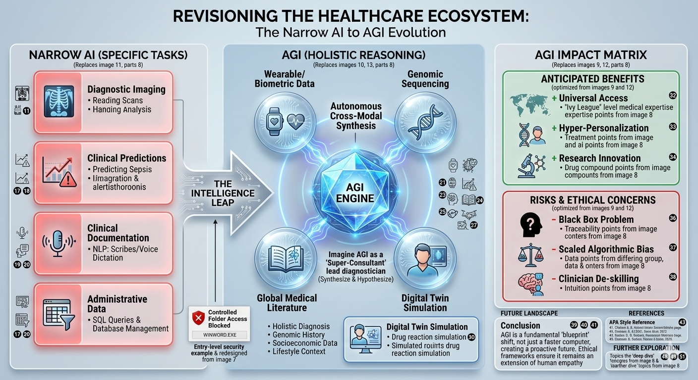

1. Introduction
Artificial General Intelligence (AGI) represents the "Holy Grail" of computer science as a system capable of understanding, learning, and applying knowledge across any intellectual task that a human can perform. While current Artificial Intelligence is "Narrow" (designed for specific tasks like SQL queries or image recognition), AGI possesses cross-domain reasoning. In healthcare, this means a system that doesn't just read a scan, but understands the patient’s genetic history, lifestyle, and socioeconomic barriers simultaneously to provide holistic care.

2. Industry Analysis: The Current State of Healthcare
Current Challenges
- Data Silos: Patient data is often trapped in fragmented systems (DDL/DML structures that don't talk to each other).
- Burnout: Physicians spend over 50% of their day on administrative tasks rather than patient care.
- Diagnostic Errors: Human fatigue and the sheer volume of medical literature (which doubles every 73 days) lead to missed diagnoses.
Baseline: Current AI vs. AGI
Today, we use Narrow AI for:
- Radiology: Detecting tumors in X-rays.
- Predictive Analytics: Identifying patients at risk for sepsis.
- NLP: Scribes that record patient visits. The Limitation: These tools cannot "reason." A radiology AI cannot explain how a patient's recent job loss might be contributing to the physical symptoms seen on a scan.

3. AGI Application Proposal
Defining the AGI Shift
Unlike Narrow AI, AGI would feature autonomous reasoning and cross-modal synthesis. It could "study" every medical journal ever written while simultaneously managing a hospital's entire supply chain and patient load.
Specific Use Case: The "Super-Consultant"
Imagine an AGI system acting as the lead diagnostician. It would:
- Synthesize: Combine real-time wearable data (heart rate, sleep) with genomic sequencing and environmental data.
- Hypothesize: Unlike SQL queries that look for "what is," AGI asks "what if?" It could simulate a patient’s reaction to a new drug in a digital twin environment before the first dose is administered.

Anticipated Benefits
- Universal Access: AGI could provide "Ivy League" level medical expertise to remote areas at a fraction of the cost.
- Hyper-Personalization: Moving from "one size fits all" medicine to treatments designed specifically for your unique DNA.
- Innovation: AGI could identify new drug compounds by finding patterns in biochemistry that human researchers haven't even thought to look for.
Risks and Ethical Concerns
- The Black Box Problem: If an AGI makes a life-or-death decision, can we trace its logic?
- Bias: If the training data (DML) is biased against certain demographics, the AGI will scale that bias at an alarming rate.
- De-skilling: Over-reliance on AGI could lead to a decline in human clinical intuition.
4. Conclusion
AGI is not merely a faster computer; it is a fundamental shift in the "blueprint" of how we solve human problems. In healthcare, it offers a future where no disease goes undiagnosed and care is truly proactive. However, the transition must be governed by strict ethical frameworks to ensure the "machine" remains an extension of human empathy, not a replacement for it.

5. References (APA Style Examples)
- Bostrom, N. (2014). Superintelligence: Paths, Dangers, Strategies. Oxford University Press.
- Topol, E. J. (2019). Deep Medicine: How Artificial Intelligence Can Make Healthcare Human Again. Basic Books.
- OpenAI. (2023). Planning for AGI and Beyond. Retrieved from [OpenAI website].

Expanding to 2,000 Words: A Strategy
To hit your length requirement, focus on these "deep dives":
- Technical Nuance: Spend 400 words explaining the difference between Deep Learning (today) and Recursive Self-Improvement (AGI).
- Economic Impact: Add a section on how AGI could change the "Cost of Care" curve.
- Real-World Analogies: Use your database knowledge! Compare the current "relational" way we store medical data to how an AGI would likely use a "vectorized" neural memory to access information.

